For Immediate Release

NC State University settles complaint alleging
disability discrimination in student housing
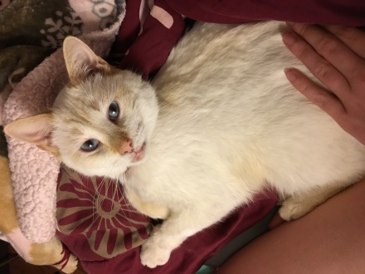
RALEIGH, October 11, 2017 – Legal Aid of North Carolina announced today that it had recently settled a federal discrimination complaint filed against North Carolina State University on behalf of Laura Auman, a student with a disability.
In the complaint, filed with the U.S. Department of Housing and Urban Development in 2016, Ms. Auman alleged that the university violated the federal Fair Housing Act by denying her request to keep her emotional support animal, a cat named Kifree (pictured), in her university-operated student housing unit as a reasonable accommodation of her disability. At the time, the university had no emotional support animal policy and stated that it could not implement one for several more semesters.
Under the settlement, the University agreed to:
- require Fair Housing Act training, with an emphasis on reasonable accommodations, for all employees in University Housing, the Office for Institutional Equity and Diversity, and the Disability Services Office who directly engage with students seeking reasonable accommodations;
- display a HUD Fair Housing poster throughout all University Housing units and offices in a location that is visible to all entering the premises, as well as on the websites of University Housing and the Disability Services Office;
- publicize on relevant University websites its new Assistance Animal policy allowing persons with disabilities to keep animals with them in University housing when such animals provide necessary therapeutic benefits to such students; and
- pay an undisclosed monetary amount to Ms. Auman.
The University further acknowledged that it has an affirmative duty not to discriminate under the Fair Housing Act. The law prohibits discrimination in housing on the basis of race, color, religion, national origin, sex, familial status, and disability.
“The Fair Housing Project of Legal Aid is committed to ensuring that students in university housing, just like all residents of North Carolina, are afforded the protections of the Fair Housing Act,” said Jack Holtzman, co-director of the Fair Housing Project. “Those protections include making accommodations for students with disabilities who need emotional support animals in order to have an equal opportunity to enjoy the benefits of university housing.”
“NC State University is to be commended for implementing a new campus-wide Assistance Animal policy and quickly reaching an agreement in this case,” said George Hausen, executive director of Legal Aid.
Ms. Auman also filed an administrative complaint in 2016 with the U.S. Education Department's Office for Civil Rights against the University, regarding the same alleged conduct. On September, 28, 2017, the Office for Civil Rights found sufficient evidence that the University violated Section 504 of the Rehabilitation Act and Title II of the Americans with Disabilities Act when it denied Ms. Auman’s request to keep Kifree, her emotional support animal, in her university housing as a reasonable accommodation of her disability.
# # #
Legal Aid of North Carolina is a statewide, nonprofit law firm that provides free legal services in civil matters to low-income people in order to ensure equal access to justice and remove legal barriers to economic opportunity. Learn more at LegalAidNC.org.
Legal Aid’s Fair Housing Project works to eliminate housing discrimination and to ensure equal housing opportunity for all people through education, outreach, public policy initiatives, advocacy and enforcement. North Carolinians who believe that they have been victims of housing discrimination can contact the Fair Housing Project at 1-855-797-3247 or info@fairhousingnc.org. The project’s work is made possible by a grant from the U.S. Department of Housing and Urban Development’s Fair Housing Initiatives Program. Learn more about the project and fair housing laws at FairHousingNC.org.

Media Contacts
George Hausen, Executive Director, Legal Aid of N.C., 919-856-2130, GeorgeH@legalaidnc.org
Jack Holtzman, Co-Director, Fair Housing Project, 919-856-2165, Jack@ncjustice.org
Sean Driscoll, Director of Public Relations, Legal Aid of N.C., 919-856-2132, SeanD@legalaidnc.org

